Plant Gnome Instructions

Materials: 1 craft stick 1 long chenille 1 short chenille 1 cotton circle 1 fabric square 1 pompom 2 felt triangles
stem stem

1 gluestick

(chenille stems are pipecleaners)

1. Wrap the long chenille stem around the middle of the craft stick.

2. Slip the fabric square over the craft stick through the hole in the middle
of the square. Wrap the short chenille stem around the fabric square under
the gnome’s “arms” as a belt.

3. Put glue on the craft stick just above
the fabric square and glue on the cotton
circle as the gnome’s beard. Be sure to put
the glue on the stick and not on the cotton
circle.

4. Rub the pompom on the gluestick and glue
it to the stick above the beard as the gnome’s nose.
5. Put glue on the stick above the nose and glue on one
felt triangle. Turn the stick over and glue the other
felt triangle to the back of the stick to make the back of
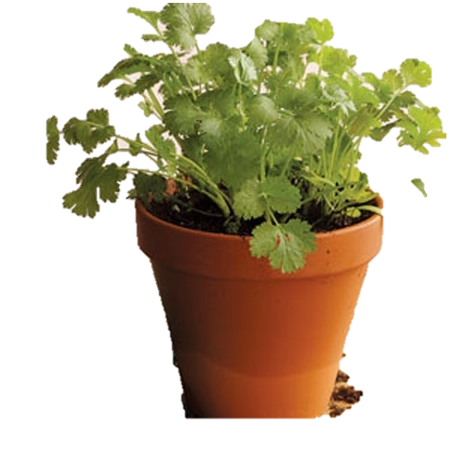
the gnome’s hat.

Add your gnome
to a potted plant
and enjoy!

